PWM Input

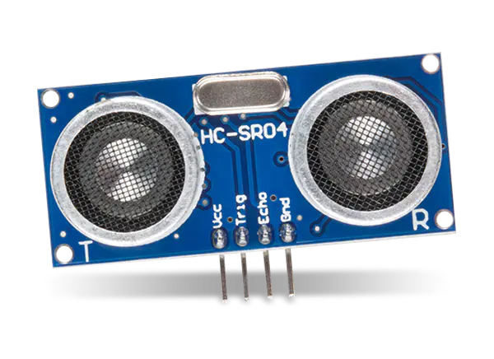

Semester 3 Embedded Systems

Lab_05_PWM_Input

Nov 20, 2022.

Student: Andre Sanao

Course: Technology

# Introduction

During the previous assignment, Timer output was used to manipulate the Pulse Width Modulation{PWM) in order to change the servo motors frequency and direction. In this assignment, another feature of the Timer will be added which is the input function. This feature will be demonstrated with the use of an Ultrasonic Sensor(HC-SR04). The following section will further explain the implementation of Timers input.

# Research

This section extends the research of the previous assignment report and will cover the features which are useful for handling any time related events, generate waveforms and measuring/counting the timing characteristics of input signals using input capture mode. In Input capture mode captures both rising edge and falling edge to measure pulse width. The hardware which is the Ultrasonic sensor copies the counter to capture/compare register(CCR) and generates an interrupt to run timer ISR() using either edge of an external signal. The time span between two events measures the distance of the object.

# Design

Figure Input Capture Diagram

In figure 1 shows an example of how the input signal is collected and display value. The input values enter through a digital filter is made of an event counter in which N consecutive events are needed to validate a transition on the output. The edge detector block detects rising or falling edge(for the hardware, rising edge was used). Input prescaler block resets as soon as the capture compare output is 0. The top blocks handle the interrupts of the hardware. The hardware sets these flags and the software needs to clear them. The bottom block triggers DMA requests.

# Testing

This section will demonstrate the implementations of Timers input. The Ultrasonic sensor will be used to transmit timer output signals in block form and the input will detect the echo distance using rising edges.

Timer output trigger pin must have a pulse of HIGH with at least 10 microseconds. This will initiate the sensor transmitting 8 cycles of ultrasonic burst at 40Khz and wait for the reflected burst. When the sensor detects the ultrasonic from the receiver, it will set the echo pin to HIGH and delay for the width of the period which proportion the distance. The distance can be obtained by measuring the on time(Ton) of the echo pin. The echo value can be converted to centimeters by dividing it with 58.

During the testing some minor problems were discovers where the trigger pin would fluctuate between 8 and 12 microseconds. This puts the sensor with to show inaccurate values but so miniscule that it won’t affect function of the hardware.

LED’s was used to visualize if the hardware is capturing the objects in certain distance. If the objects were close enough the first LED would turn on and the object were to get closer, the second LED would also turn on.

# Conclusion

The learning outcome of this assignment will be a feature that will implemented in the Robot project. Attempting to get the 10 microseconds for the output timer was frustrating and without the use of a logic analyzer, this assignment would be almost impossible to complete.

There are some notes that needs to be taken account which is connecting the ground pin first before the voltage pin. If this is done incorrectly, the ultrasonic IC chip would burn and will be of no use anymore.

# Bibliography

STMicroelectronics NV. (2017). *RM0316 Reference manual* [Ebook]. Retrieved from <https://www.st.com/resource/en/reference_manual/dm00043574-stm32f303xb-c-d-e-stm32f303x6-8-stm32f328x8-stm32f358xc-stm32f398xe-advanced-arm-based-mcus-stmicroelectronics.pdf>

STMicroelectronics. (2018). STM32F303xB STM32F303xC [Ebook]. Retrieved from <https://www.st.com/resource/en/datasheet/stm32f303vc.pdf>

(no date) *Embedded systems with ARM cortex-M microcontrollers in assembly language and C*. Available at: <https://web.eece.maine.edu/~zhu/book/> (Accessed: November 21, 2022).